Improvements to Internal Business Processes at BOLDFlash

Smokie Lee

Southern New Hampshire University

The communication environment that exists within BOLDFlash is one of unproductive conflict between the main departments as evidenced by Roger Cahill (Beer & Shelton, 2012). Particular areas of concerns include ambiguous language, significant knowledge gaps between departments, assumptions regarding processes or input (see Appendix C), and business processes often lack definition with regards to roles and responsibilities (see Appendix A). Lack of consideration for current manufacturing processes from product development also causes issues, and lack of understanding of business processes from other departments (Beer & Shelton, 2012) has contributed to the situation. The area of focus should be internal business processes because these processes dictate how departments work with one another, and therefore help steer the success of the company. Once improvements have been made to these processes, more communication improvements can be made to both internal and external communications.

The key stakeholders in developing and maintaining internal business processes are the management: Kevin Cheng, Director of Manufacturing; Karl Melzer, Director of Product Development; Kavita Patel, Director of Marketing; and Chip Bryant, Director of Sales. These directors are all involved in the internal business processes and will have a direct responsibility to implement any proposed changes, so their inclusion is vital. Being included also provides other stakeholders insight to processes outside their area of responsibility, building a stronger rapport between teams and fulfilling their responsibility to “encourage and foster a culture of collaboration” (Lash, 2012).

To be the most effective, the framework for communication must have clear processes, be standardized across the departments, and create a culture of collaboration. Rather than discussing processes and pain points internally (see Appendix B), regular process audits where those involved can voice their concerns and suggestions should be conducted to determine if the process is effective (“Process Auditing,” n.d.). Such an environment should foster trust between departments while also challenging assumptions and generating new ideas.

Regarding internal communication, there are several established communication practices that can be utilized. Because communication often includes many departments, context should be included in the communication. Including specific details and information is a good way to do this. For example, in the memo from Product Development (see Appendix A) instead of saying "Kevin's admin assistant" the memo should instead include her name. A link to the product documentation should be included as well, or instructions on how to receive that information if needed. In the Marketing memo (see Appendix C), the enhancements should be explained or at least touched upon.

Language for internal communications should be clear and concise; one should write to express not to impress. Usage of idioms like “rock the boat” and puns such as “generate some ‘flash’” (see Appendix C) should be avoided in technical communication. Abbreviating words without explanation should be avoided to lessen confusion (see Appendix A), even when communicating internally; your initial audience isn’t necessarily your final one (Gerson & Gerson, 2013). The current language is too internally focused and doesn’t provide a compelling reason for the reader to follow the communication (see Appendix B). This can lead to confusion and conflict.

Lastly, presenting the communication in a problem/solution setup would make the memos more effective. By presenting the problem and offering a solution, internal communications can provide more context and information which will allow stakeholders to make effective decisions. For example, the sales memo (Appendix B) should include the problem (delivery dates not being met) and what they believe is the cause of the problem. The Marketing memo (Appendix C) could include what problems the requested enhancements are solving.

The communication environment that exists within BOLDFlash is one of unproductive and unnecessary interdepartmental conflict resulting from lack of clearly defined business processes. Internal business processes and communications are filled with ambiguous language, significant knowledge gaps, and assumptions on all sides, and they lack definition with regards to roles and responsibilities. To solve this, internal communications should be improved to provide specific details using clear language, and regular process audits including all key stakeholders should be held to evaluate the continued success of the framework.

References

Ashkenas, R. (n.d.). Your Communications May Not Be Communicating. Retrieved October 8, 2015, from https://hbr.org/2011/02/your-communications-may-not-be

Beer, M., & Shelton, R. (2012). *BoldFlash: Cross-Functional Challenges in the Mobile Division* (No. 4438) (p. 10). Harvard Business Publishing: Harvard Business School.

Gerson, S. J., & Gerson, S. M. (2013). *Technical Communication: Process and Product*. Pearson.

Larson, G. (n.d.). The Foundation of Successful Collaboration in Technical Writing. Retrieved October 12, 2015, from http://techwhirl.com/the-foundation-of-successful-collaboration/

Lash, R. (2012). The Collaboration Imperative | Ivey Business Journal. *Ivey Business Journal*, (January/February 2012). Retrieved from http://iveybusinessjournal.com/publication/the-collaboration-imperative/

Process Auditing. (n.d.). Retrieved October 12, 2015, from http://transition-support.com/Process-Auditing_Technique.htm

Purdue OWL: The Rhetorical Situation. (n.d.). Retrieved October 8, 2015, from https://owl.english.purdue.edu/owl/resource/625/11/

Appendix A

Product Development Internal Memo

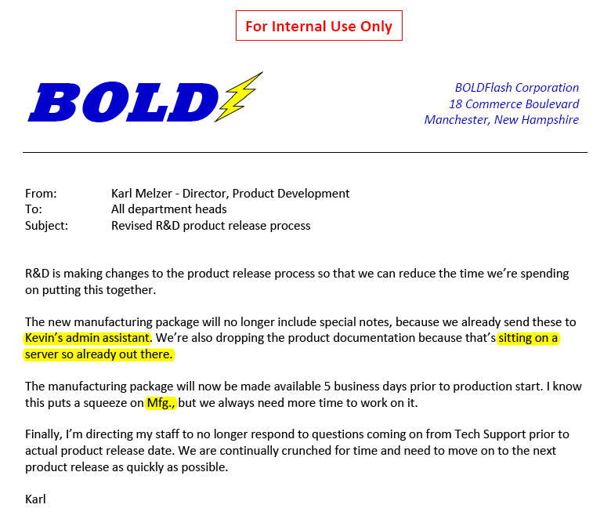

Appendix B

Sales Internal Memo

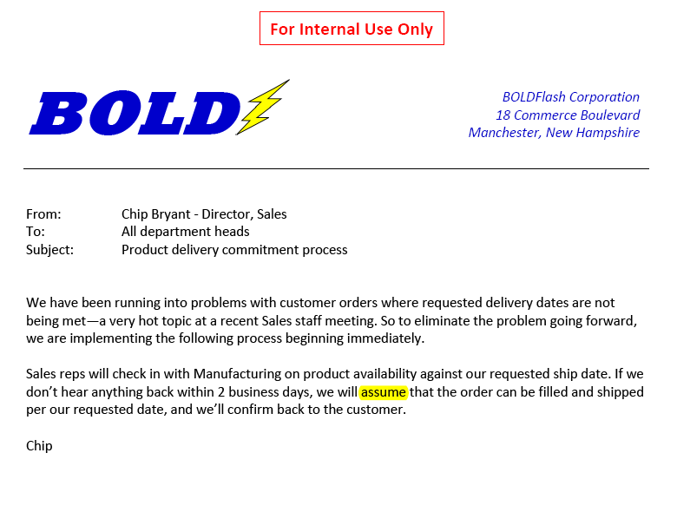

Appendix C

Marketing Internal Memo

